Title:
Students Name
Institution Affiliation

### Answer short questions (2 marks, 0.5 each)
* What are the major Python versions? Are they inter-compatible?
The major versions of pythons include python 1.0. python 2.0, python 3.0. These python versions are inter-compatible.
* What are the advantages and disadvantages of a scripting language like Python?
On advantage of scripting language is that the ease of use and mastery; hence, those with minimum or basic knowledge in programming can be able to use it. Besides, it is fast ion running codes and also has many code editors hence effective in code editing. It facilitates faster performance of complex tasks. The main disadvantage is that it can be easily hacked.
* Name one Python package each for
* numeric calculation- NumPy
* image processing- SciPy
* data visualization- IPython
* machine learning- Scikit-learn
* Explain the difference between mutable and immutable objects. Give an example for each.
Mutable objects-objects that once can change states and fields after the object is created. Examples include String Builder
Immutable objects-this are objects that nothing can be changed after the object has been created. An example is Long or Integer
## Functions (2 marks, 0.5 each)
* How to indicate a code block in Python?
Code blocks in Python are indicated by identifying each line of the block by the same amount. The aim is not just to make the code beautiful but to indicate which block of code the statement belongs to.
* Explain the difference between local scopes and global scopes;
Local scope occurs when a variable is declared within a programming block while the global scope is defined outside the function or subroutine. Thus, this means that local scope can only be used inside the subroutines where declared and exists until when the block of the function is under execution and then destroyed automatically. Global variables are never destroyed automatically after execution of the function, as they hold values all through the lifetime of the program.
* Refer to Code 1 - 3 below and infer the difference between keywords `global` and `nonlocal`;
The use of “global” inside the nested function seems not to affect the variable x, (x=2 for code 1 and code 2). Therefore, the use of the global keyword does not affect the namespace of their enclosing namespace. The term is therefore used to make a global declaration. Use of the term non-loca changes the x-variable in the function (inside function x=5, and outside function x=10
* Compare Code 4 and Code 5, explain why Code 5 can change the value of `x`. Hint: is it a new assignment or an in-place change?
The value for 'x' changes in code 5 because it's a new assignment, while code 4 is an in-place assignment.

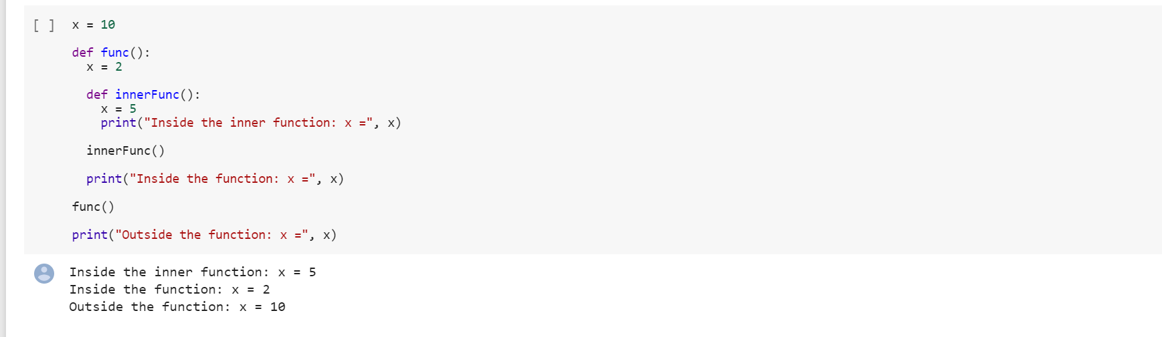

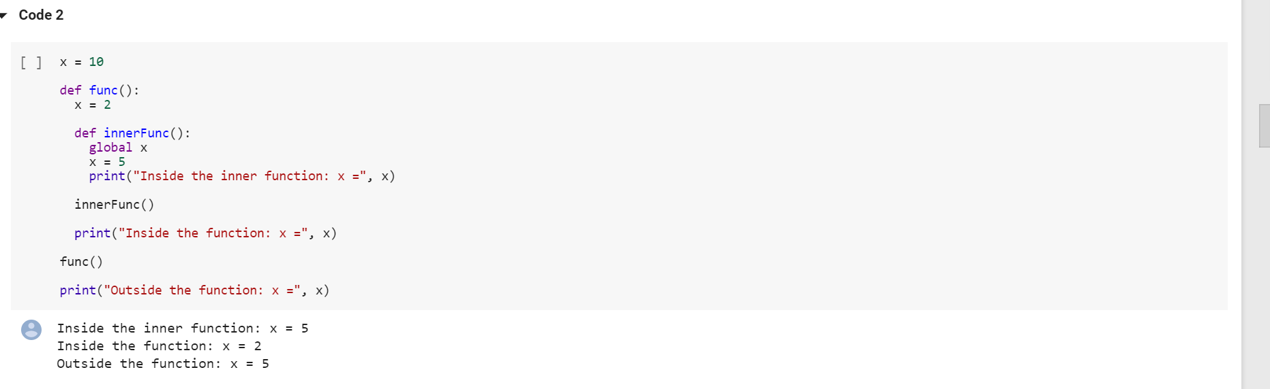

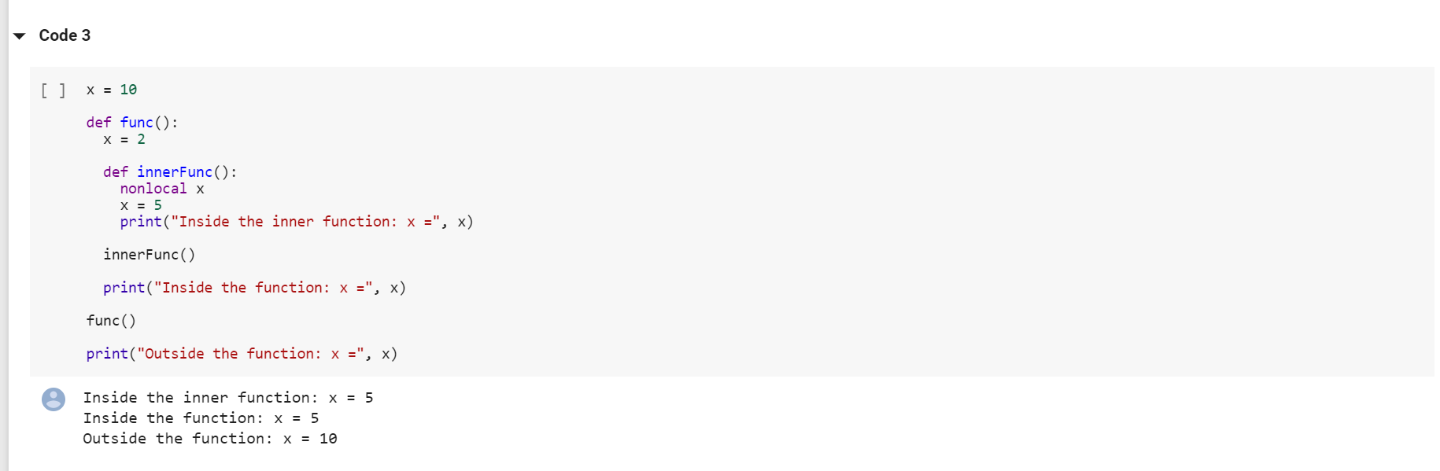

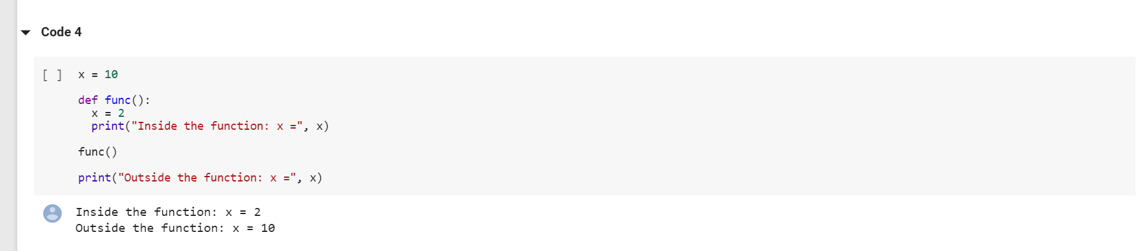

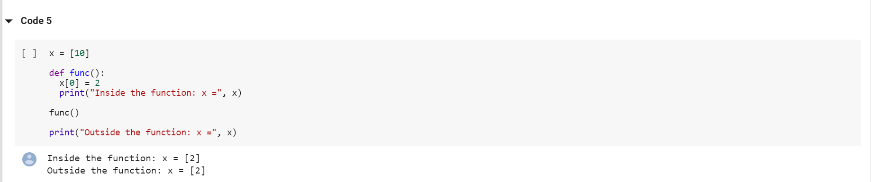

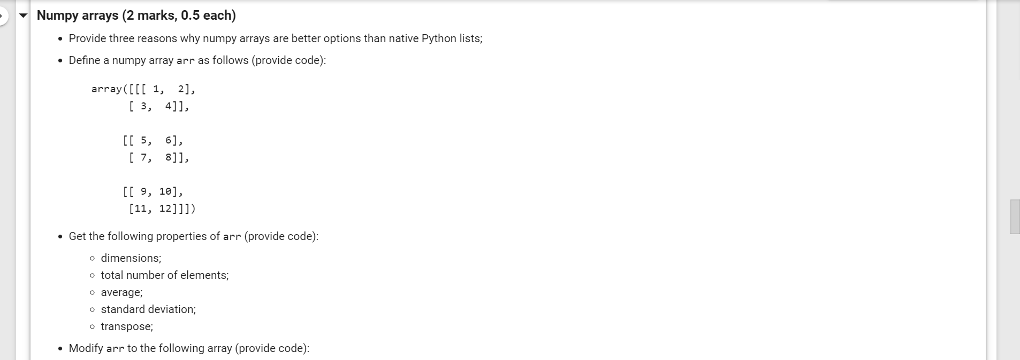

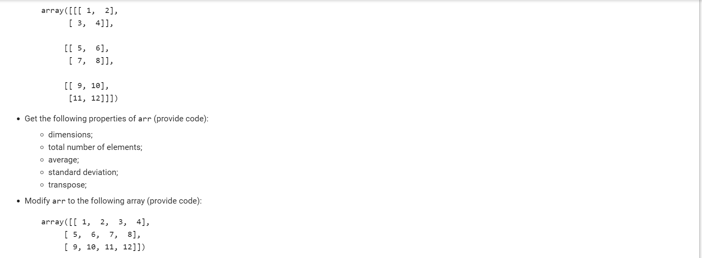
Reasons why numpy arrays are better options than native python list
NumPy arrays are smaller and have higher speed and performance than the python List
They have s memory consumption.
They have better run-time behavior compared to Python List
Define Numpy array arr as follows (provide code)
Array arr =
array([[[1,2],[3,4]],[[5,6],[7,8],[[9,10],[11,12]]]])
b = np.arange(start=1, stop=13)
b.shape = 6,2
print(b)
Get the following properties of arr
Dimension:
print(b.ndim)
number of elements
print(b.size)
Average of the array arr:
Code c = np.average(b)
Print(c)
The standard deviation of the array arr
d = np.std(b)
Print(d)
The transpose of the array arr
print(b.T)
Modify arr to the following array (provide code)
Array = ([[1,2,3, 4],
[5,6,7,8],
[9,10,11,12]])
Import numpy as np

z = np arrange(start=1, stop=13)
z.shape = 3,4
print(z)
### Explain terminologies (1 mark)
* Supervised vs unsupervised learning
In supervised learning, all the data is labeled, and the algorithms learn to predict the output from the data. On the other hand, in unsupervised learning, all the data is unlabeled. Besides, all the algorithms learn to inherent structure from the input data
* Training vs testing
Data training involves the use of a dataset that contains outcomes to train the machine while testing involves the use of a data set that does not have outcomes to predict the outcome.
* Overfitting-
Occurs when a machine learning algorithm or statistical model learns and captures details of the noise during data training such that its performance is affected.
* Gradient descent
It is an optimization algorithm that is used to find the minimum of a function.
### Data partitioning (1 mark)
Propose a data partitioning plan if the model has several hyper-parameter to be determined.
If the model has several hyper-parameter to be determined, partitioning can be done using the random embedding’s or by use of Gaussian processes.
### Explain terminologies (1 mark)
* Neural networks
These are a subset of learning algorithms in a machine learning field that are based on the neural network concept in human bodies.
* Weights and biases
Weights are used in the neural network to increase the steepness of activation function, while biases cause a delay in the activation function.
* Backpropagation
A message informing the networks if a mistake has been made or not, therefore, being the centre for neural networks.
* Activation functions
Used in artificial neural networks to define the output of a node having the input or set of inputs.
### Convolutional neural networks (1 mark)
* What are the major components of a convolutional neural network?
They include convolutional layers, pooling layers, and fully connected layers.
* What does each of these components do?
Convolutional layers filter images by reducing the inputs.
Pooling layers mover over the output of convectional layers making the image smaller
Fully connected layers are used to identify image patterns.
* When should you use a softmax activation function?
To solve a problem in a multi-class classifier by assigning an instance to one class when there is a possibility of classes being larger than two.
* What loss can you use for a multi-class classification task?
The loss function

